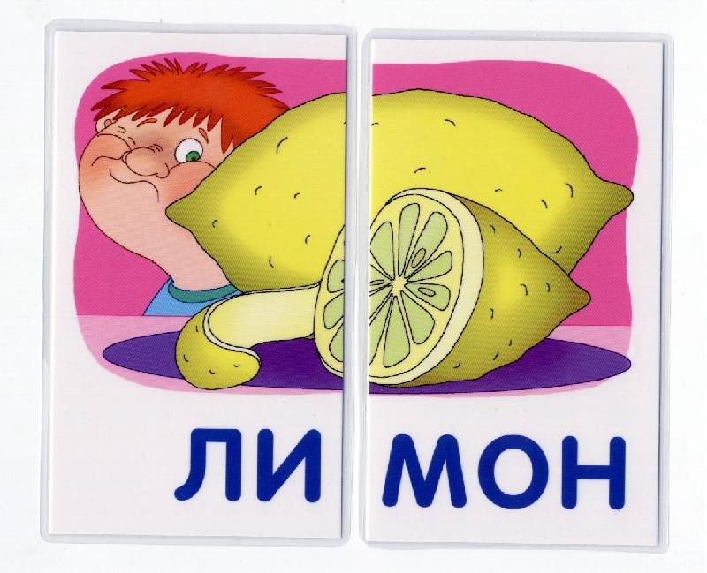

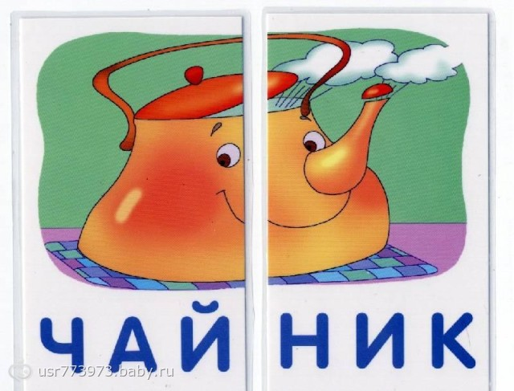

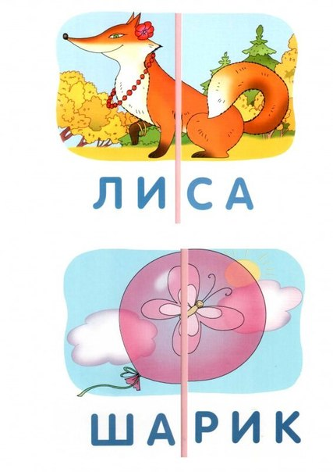



|  |  |
| --- | --- |
| **ЛИ** | **ЛИ** |
| **МОН** | |
| **СА** | **ША** |

|  |
| --- |
| **РИК** |
| **ЧАЙ** |
| **НИК** |